Exercise 3: Stored Procedures

BY: Shubham Sangram Bej

Aim
To implement PL/SQL stored procedures for automating banking operations such as processing monthly interest, updating employee bonuses, and transferring funds securely between accounts.

Scenario 1: Process Monthly Interest

Problem Statement
The bank needs to process monthly interest for all savings accounts. Write a stored procedure ProcessMonthlyInterest that calculates and updates the balance of all savings accounts by applying an interest rate of 1% to the current balance.

Algorithm
- Select all Savings accounts.
- Calculate 1% of the current balance.
- Update the account balance.
- Commit the transaction.
- Display a success message.

Program
CREATE OR REPLACE PROCEDURE PROCESSMONTHLYINTEREST AS
BEGIN
UPDATE ACCOUNTS
SET
BALANCE = BALANCE + ( BALANCE * 0.01 )
WHERE
UPPER(ACCOUNTTYPE) = 'SAVINGS';

COMMIT;
DBMS_OUTPUT.PUT_LINE('Monthly interest of 1% has been credited to all Savings accounts.');
END;
/

BEGIN
PROCESSMONTHLYINTEREST;
END;
/

Output
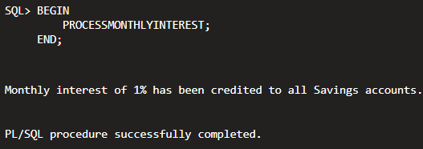

Updated Accounts Table
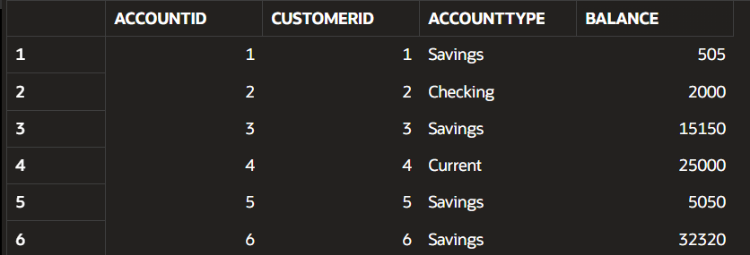

Scenario 2: Update Employee Bonus

Problem Statement

The bank wants to implement a bonus scheme for employees based on their performance. Write a stored procedure UpdateEmployeeBonus that updates the salary of employees in a given department by adding a bonus percentage passed as a parameter.

Algorithm
- Accept department name and bonus percentage.
- Update salaries of matching employees.
- Commit the transaction.
- Display the number of employees updated.
- Display a message if no matching department exists.

Program
CREATE OR REPLACE PROCEDURE UPDATEEMPLOYEEBONUS (
P_DEPARTMENT IN VARCHAR2,
P_BONUS IN NUMBER
) AS
BEGIN
DBMS_OUTPUT.PUT_LINE('Department received: ' || P_DEPARTMENT);
UPDATE EMPLOYEES
SET
SALARY = SALARY + ( SALARY * P_BONUS / 100 )
WHERE
UPPER(DEPARTMENT) = UPPER(P_DEPARTMENT);

DBMS_OUTPUT.PUT_LINE('Rows updated: ' || SQL%ROWCOUNT);
COMMIT;
END;
/

BEGIN
UPDATEEMPLOYEEBONUS('IT', 10);
END;
/

Output
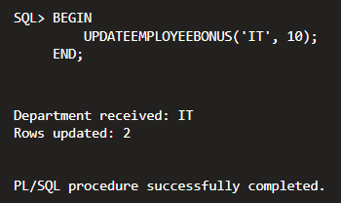

Updated Employees Table

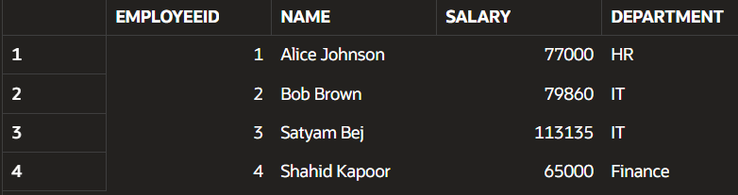

Scenario 3: Transfer Funds

Problem Statement

Customers should be able to transfer funds between their accounts. Write a stored procedure TransferFunds that transfers a specified amount from one account to another, checking that the source account has sufficient balance before making the transfer.

Algorithm
- Accept source account, destination account, and amount.
- Retrieve the source account balance.
- Verify sufficient funds.
- If sufficient:
  - Deduct the amount from the source account.
  - Add the amount to the destination account.
  - Commit the transaction.
- Otherwise:
  - Roll back the transaction.
  - Display an error message.
- Handle invalid account numbers using exception handling.

Program
CREATE OR REPLACE PROCEDURE TRANSFERFUNDS (
P_FROMACCOUNT IN NUMBER,
P_TOACCOUNT IN NUMBER,
P_AMOUNT IN NUMBER
) AS
V_BALANCE NUMBER;
BEGIN
SELECT
BALANCE
INTO V_BALANCE
FROM
ACCOUNTS
WHERE
ACCOUNTID = P_FROMACCOUNT;

IF V_BALANCE < P_AMOUNT THEN
DBMS_OUTPUT.PUT_LINE('Transfer failed. Insufficient balance.');
ROLLBACK;
ELSE
UPDATE ACCOUNTS
SET
BALANCE = BALANCE - P_AMOUNT
WHERE
ACCOUNTID = P_FROMACCOUNT;

UPDATE ACCOUNTS
SET
BALANCE = BALANCE + P_AMOUNT
WHERE
ACCOUNTID = P_TOACCOUNT;

COMMIT;
DBMS_OUTPUT.PUT_LINE('Funds transferred successfully.');
END IF;

EXCEPTION
WHEN NO_DATA_FOUND THEN
DBMS_OUTPUT.PUT_LINE('Account not found.');
ROLLBACK;
WHEN OTHERS THEN
DBMS_OUTPUT.PUT_LINE('Error: ' || SQLERRM);
ROLLBACK;
END;
/

BEGIN
TRANSFERFUNDS(1, 2, 300);
END;
/

Output
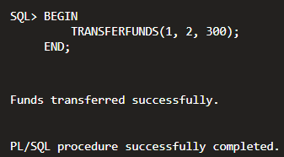

Updated Accounts Table
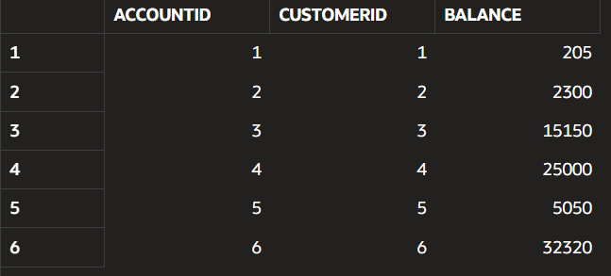

Conclusion
This exercise demonstrated the use of PL/SQL stored procedures to automate repetitive banking operations. Procedures were created to process monthly interest, update employee bonuses, and transfer funds securely. Transaction control using COMMIT and ROLLBACK, along with exception handling, ensured that database consistency and integrity were maintained throughout each operation.

